Exp 4 main

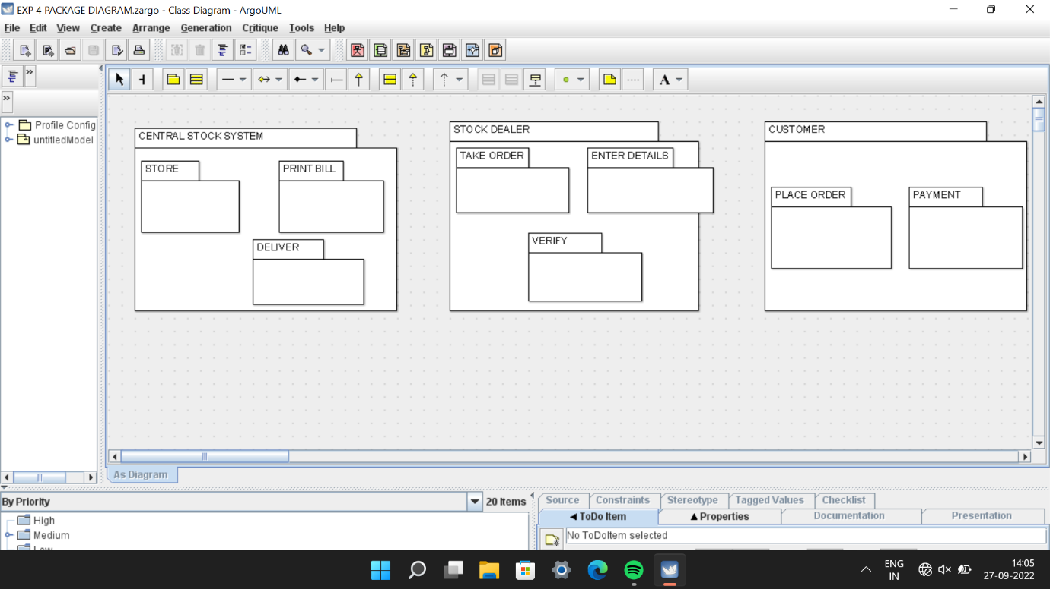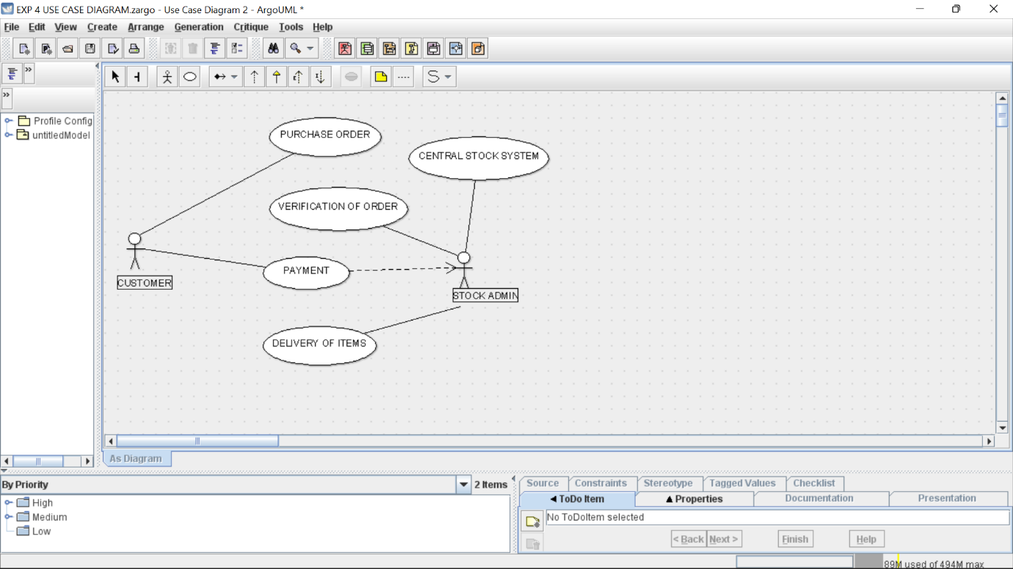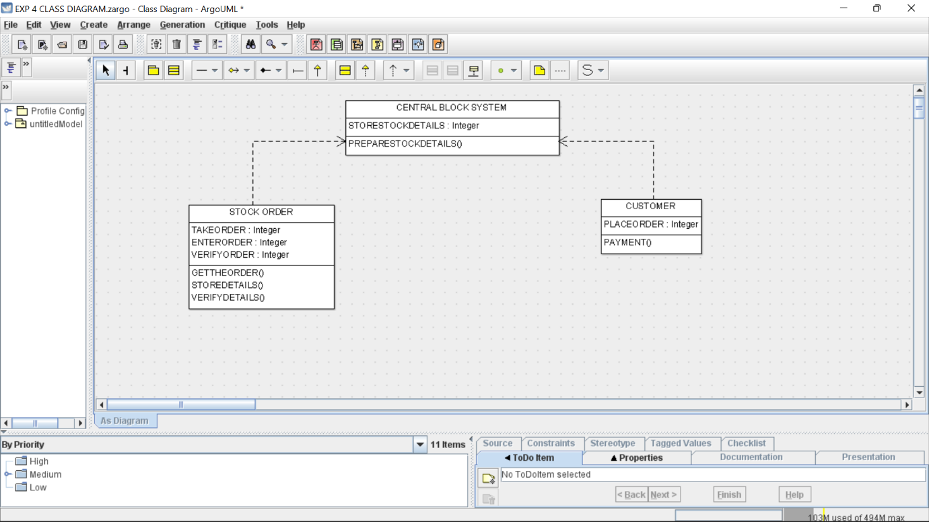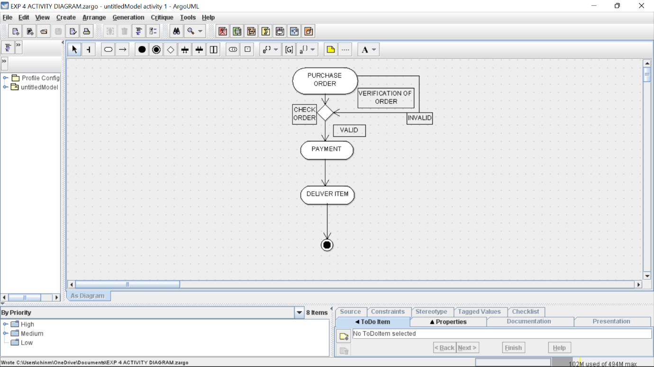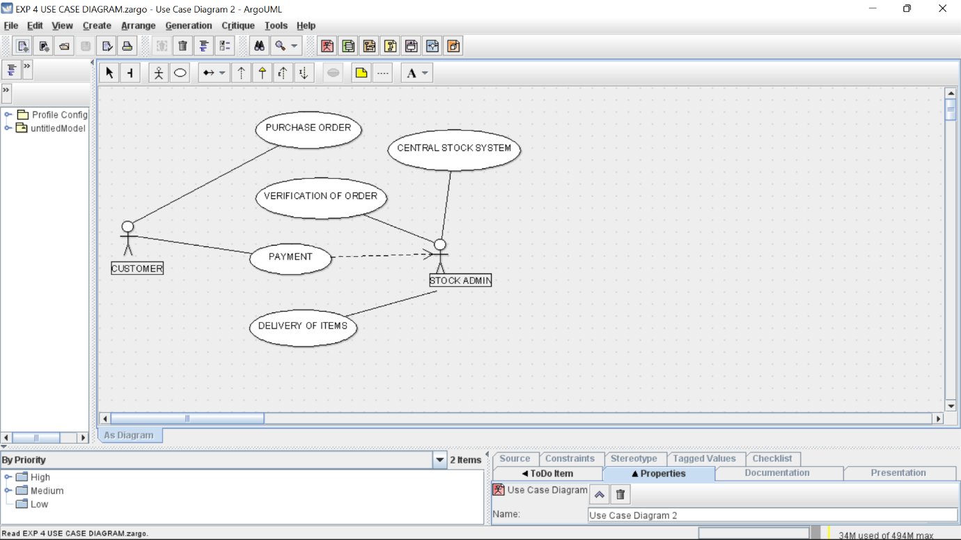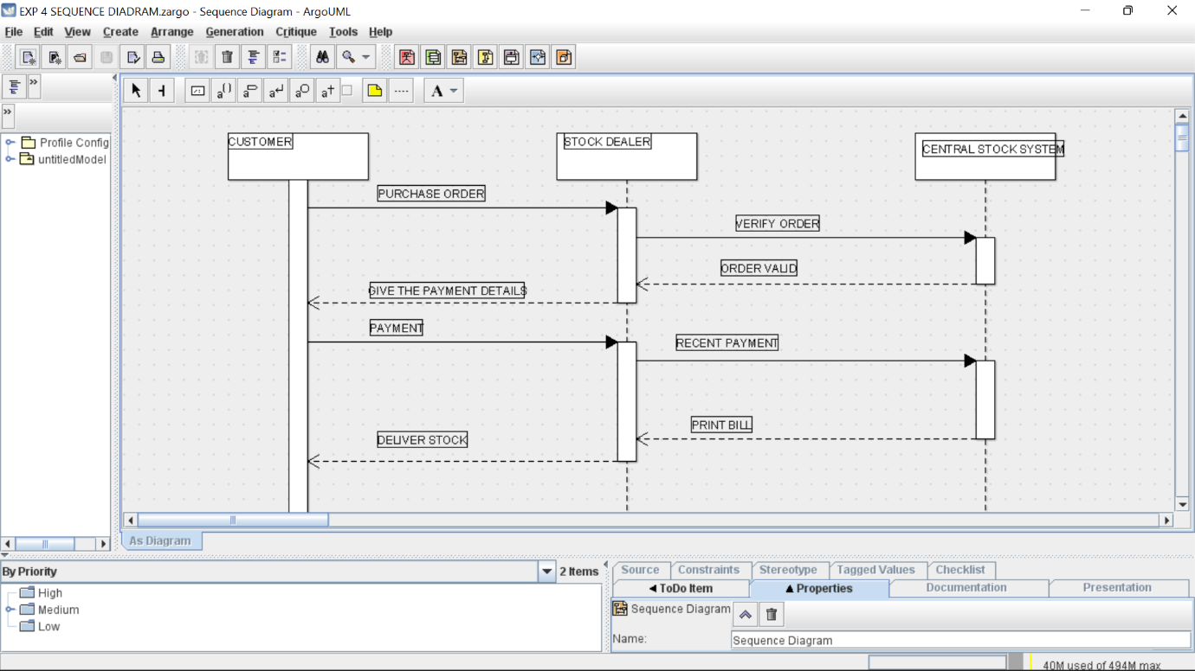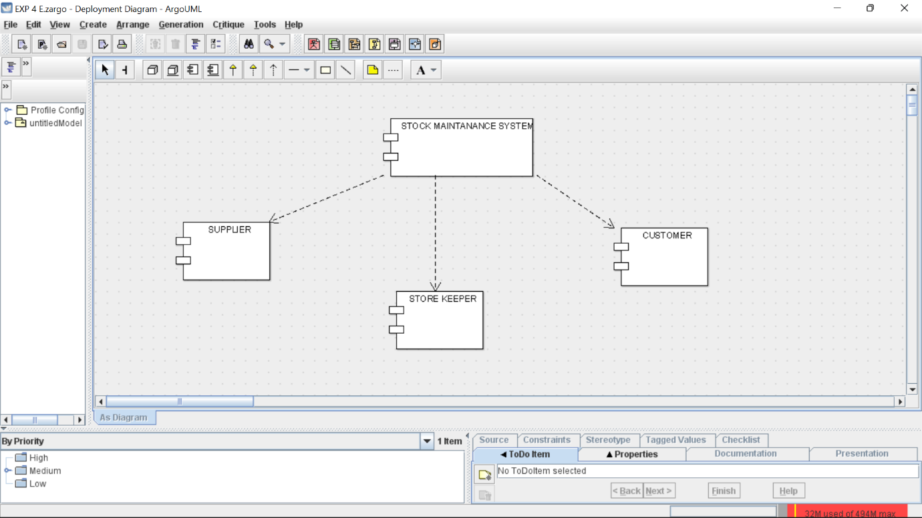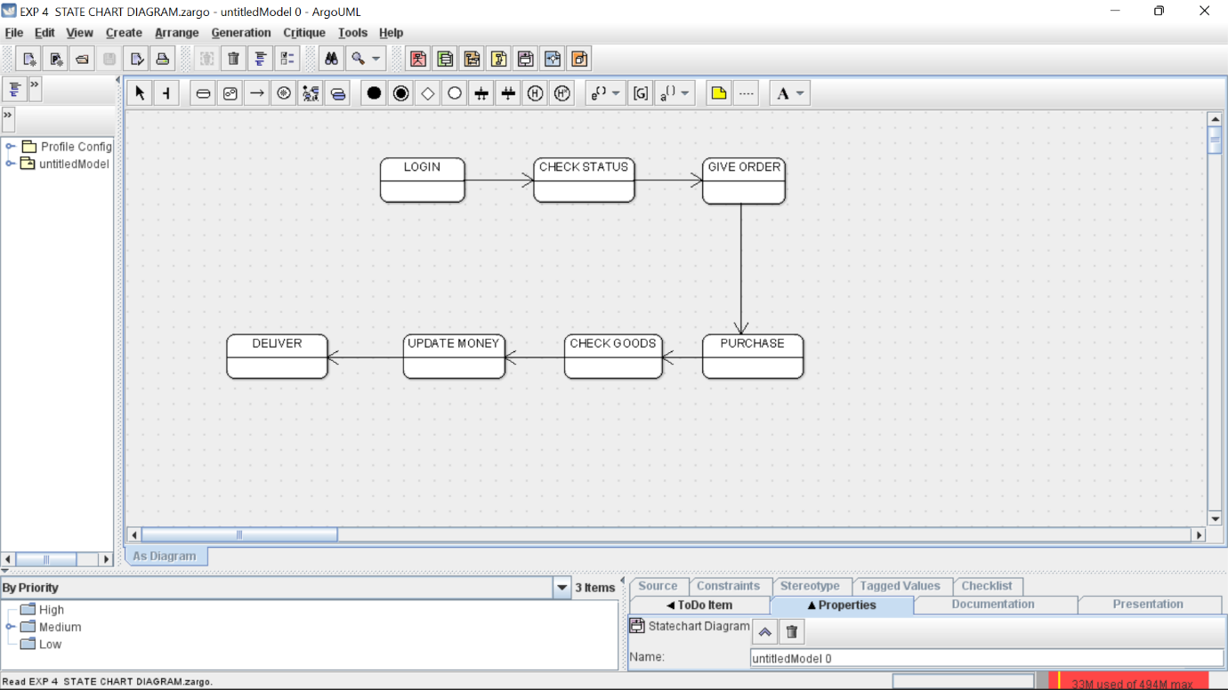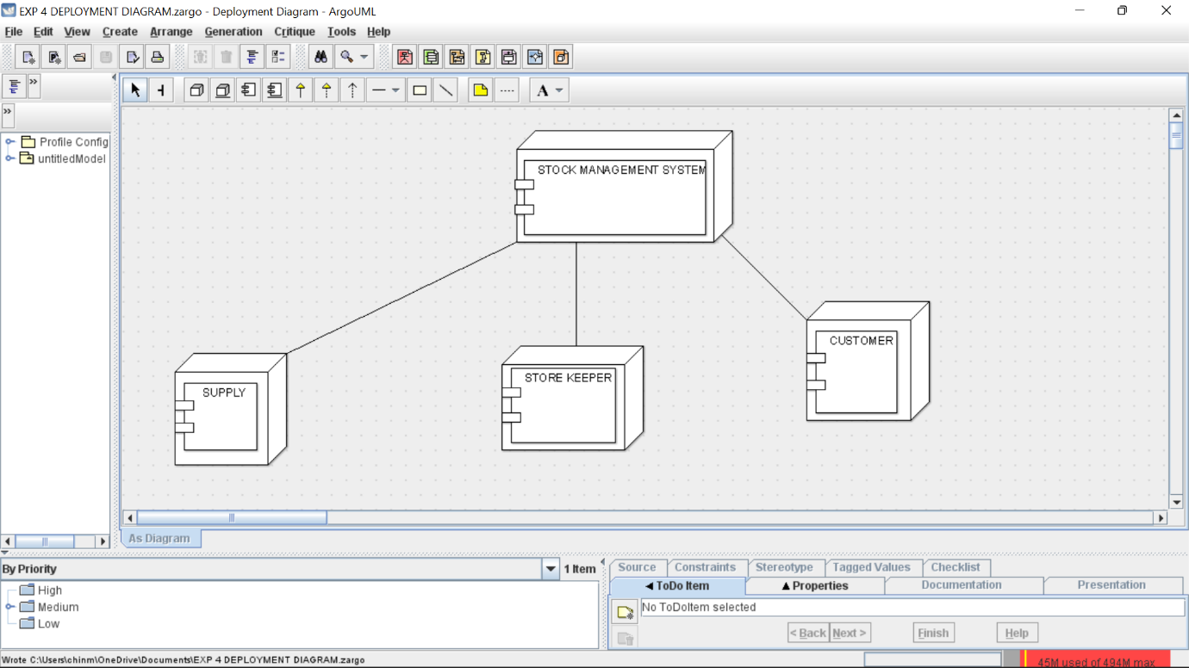

Skeleton

public class STOCK ORDER {

public Integer TAKEORDER;

private Integer ENTERORDER;

public Integer VERIFYORDER;

public void GETTHEORDER() {

}

public class CUSTOMER {

public Integer PLACEORDER;

public void PAYMENT() {

}

}

public void STOREDETAILS() {

}

public void VERIFYDETAILS() {

}

}

public class CENTRAL BLOCK SYSTEM {

public Integer STORESTOCKDETAILS;

public void PREPARESTOCKDETAILS() {

}

}